Somaliland Marathon

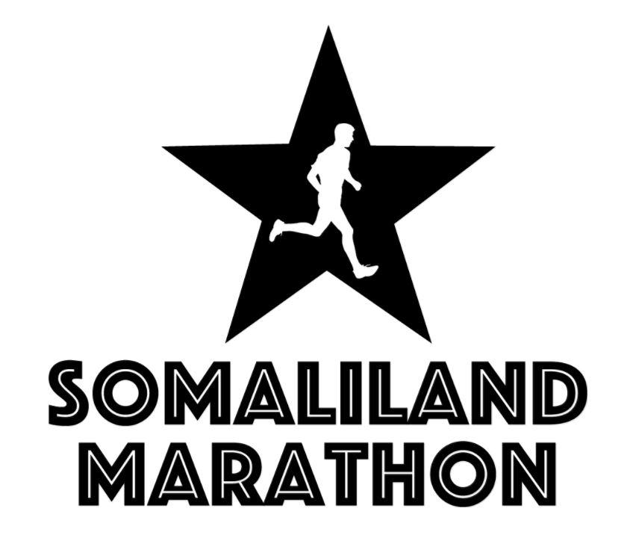

Terms and conditions of entry to the Event for Participants and Volunteers

IMPORTANT - These terms and conditions ("Conditions") govern Participants of and Volunteers to the Somaliland Marathon 2018 (the “Event”). You should read them carefully prior to registering for the Event. You should only register and participate in the Event if you have read, understood and agreed with these Conditions. These Conditions represent a legally binding agreement between you and Somaliland Marathon (“SM”), a company currently being registered in the Self-Declared Republic of SomalilandThese Conditions shall become binding on you and us when we issue you with written confirmation that you have successfully registered for the Event, usually by email.

SM have written these Conditions in what is hoped you will find to be simple English. If there is any part of them that you do not understand you should contact us. The contact details are set out below. SM will answer any queries that you may have either about these Conditions or any other aspect of the Event.

- Inherent risks of travelling to and running long distances in Somaliland

SM think it is essential to be open and transparent about the situation in Somaliland, the level of infrastructure and creature comforts that you can expect whilst in the country for the Event, and the risks inherent to competing in the Event. You should therefore read this section carefully to ensure that you enter the Event "with your eyes open". However, you should also carry out your own research on Somaliland to satisfy yourself that the Event is suitable for you and be aware of the advice of your own country about travel to Somaliland. By completing and signing a Registration Form for the Event, you certify that you have read, understood and agree to these Terms and Conditions.
Somaliland is on the coast of the Gulf of Aden. It declared independence after the overthrow of Somali military dictator, Siad Barre on the 18th May, 1991. The move followed a secessionist struggle during which Siad Barre's forces pursued rebel guerrillas in the territory. Tens of thousands of people were killed. Though not internationally recognised, Somaliland has a working political system, government institutions, a police force and its own currency. The former British protectorate has also escaped much of the chaos and violence that plague Somalia. Tourism infrastructure is steadily improving but, by Western standards, or even by the standards of those who have been on safari or beach holidays in East Africa, it is important to note that standards remain relatively modest.

Reconstruction continues, foreign investors are arriving and Somaliland is increasingly on the map as an adventure tourism destination. But until transport and 'getting around' become a little easier, visitors have the country pretty much to themselves.

In short, in the absence of extreme bad-luck or traveller stupidity, and despite the poor state of the transport network, the presence of various tropical diseases and a basic health-care infrastructure, the overwhelming majority of traveller visits who Somaliland are free of incident. Nevertheless, travellers should be vigilant, sensible and take the same precautions they would visiting any other foreign country.

About the Event

The Event consists of two races: a full marathon (42.2km) and a 10km run. The two races will be run in and around the capital city, Hargeisa.

Running in Somaliland in February will be challenging. It is possible that it will be a wet race. Hargeisa is located at 1,334 metres above sea-level and while this will not cause problems for most runners, this change in altitude may affect some. The roads are a mixed bag, although improvements are being made month-to-month. Currently the full marathon course is mostly on tar roads but it should be remembered that these roads are poorly maintained. Temperatures are likely to reach the mid to high twenty degrees Celsius by mid-morning on the day of the Event. Humidity may also increase the physical difficulty on the race, although this will obviously be reduced if it rains. You will need to be comfortable with the idea of running in hotter conditions than those with which you may be familiar.

SM will do our utmost to ensure runner safety, working with the local authorities to close the race routes to traffic or at least limit motorised vehicles' access to it. However, we cannot guarantee that runners will not encounter vehicles.

The Caveat

In short, SM can't promise that you'll be comfortable at all times during your time in Somaliland and, despite reasonable endeavours, it is likely that there will be times when you may be uncomfortable. But what we can tell you is that we will work as hard as possible to keep you safe. Nonetheless, you are ultimately responsible for the choices you make whilst in Somaliland, including whether or not to participate in the Event in the light of the weather conditions on the date.

DEFINITIONS

"Conditions" These terms and conditions
"Event" The Marathon and 10km race to be held on 16th February, 2018
“Event Fee” The fee paid by a Participant in respect of Registration for the Event.
"Event Package" Accommodation, transportation or meals purchased through our travel partner by a Participant or Volunteer in conjunction with the Event.
“"Non-Event Activity" Any activity, accommodation, or transportation that a Participant
or Volunteer may engage in or use whilst in Somaliland which
is/are provided directly by Somalialnd Marathon or by one of their subcontractors, or in respect of which a Participant.
"Participant" The holder of an Event Registration
"Registration Form” The electronic or hard copy form that must be completed by all
potential Participants and any permitted Substitutes
“SM” Somaliland Marathon, a charity currently being registered in Somaliland.
"Sponsors" The official sponsors of the Event
"Substitute" A replacement Participant who has been accepted by
SM as per clause 6 of this Agreement
“Volunteer” A person who has consented to assist SM in organising and managing the Event, but who is not a Participant.

2. Who Are We?

The Event is organised by SM, a company currently being registered in Somaliland. The Event office is located in Hargeisa, Somaliland. If you have any questions relating to these Conditions or the Event you should contact the SM team as set out below:

Event Team Email: info@somalilandmarathon.com. We will endeavour to respond to email messages within 3 working days.

3. General Conditions of Entry to the Event

- You certify that you are 18 years of age or older and that you have read and agreed to these Conditions. Participants under the age of 18 are required to have a parent or legal guardian agree to these Conditions on their behalf through completion of the registration form

- You agree and acknowledge that you are aware that the Event inherently involves the real risk of serious injury or even death from various causes including exertion, strenuous activity, dehydration, collisions or incidents involving other competitors, spectators, other road users and/or vehicles, aspects of the course or bad weather conditions, the specific security concerns associated with Somaliland and other causes. You understand you should not enter or participate in the Event unless you have trained appropriately, considered the inherent risks of taking part in the Event in Somaliland and had any health concerns checked by a medical practitioner.

- You further agree and acknowledge that it is your sole responsibility to obtain all necessary vaccinations and anti-malarial prophylactics before arrival in Somaliland. Failure to do so seriously prejudices your health, and also may result in the Somaliland authorities turning you back on arrival at Hargeisa Airport.

- You agree to abide by all race rules and directions we issue with respect to the Event.

- You agree not to deviate from the route for the race category you have entered.

- No drugs, illegal substances, performance enhancing substances or intoxicants (including alcohol) of any kind are permitted to be brought to the venue or used by any participant either before or during participation in the Event. SM reserves the right to refuse attendance at, or participation in, the Event by any persons found to have consumed or to have in their possession any drugs, illegal substances, performance enhancing substances or intoxicants (including alcohol) of any kind.

- You acknowledge that participation in the Event will be physically demanding and that you are aware of the nature of the Event and the associated medical and physical risks involved. You hereby affirm that you are physically capable of competing in the Event and agree that (subject to the Limitation of Liability paragraph below) SM, their officers, employees, agents, affiliates, Sponsors or medical advisers are not responsible for any injury or illness that you may suffer as a result of your visit to Somaliland or your participation in the Event.

- You undertake to personally procure fully comprehensive travel and medical insurance, including cover for emergency medical evacuation by land or air. Your policy must also cover you for your participation in the Event and you accept that it is your sole responsibility to ensure that this is the case. You also accept that SM reserves the right to demand proof that you have procured such cover and reserves the right to refuse your participation in the Event if such cover is not found to be in place. Accordingly, you must bring a copy of your insurance documents with you to Somaliland, with the relevant sections highlighted.

- In the event that in the opinion of Event staff you require medical assistance or evacuation you accept full liability, and indemnify SM, for any costs associated with such action, regardless of whether it is covered by your insurance policy.

- You give permission to our Event staff to make decisions concerning your personal medical care and treatment, and where necessary to authorise such care and treatment in emergency situations.

- You will inform us on your Registration Form, or subsequently by email, of any illness or infirmity from which you might suffer that might affect your performance or otherwise be relevant if medical treatment is needed.

- You must comply with the age requirements for entry to the Event and proof of age may be requested. The minimum age requirement as of the date of the race,to take part in each of the race distances in the Event is as follows:

Marathon (42.2km) - 18 years 10km – 16 years

Exceptions to the above age requirements may be made but only at the absolute discretion of Somaliland

3.14. You understand that our Event staff will make every reasonable effort, in the circumstances, to reach your emergency contact (if you have supplied one to us prior to taking part in the Event) regarding your medical status in the event an emergency arises. In the event that your contact cannot be reached in an emergency, you hereby give your permission to the licensed physician, dentist, athletic therapist, nurse or other medical professional whose services might be required to provide medical care and treatment.

- The personal information provided by you when registering for the Event will be stored on a secure database, will not be shared with third parties and will only be used for the functional purpose of the Event by SM, Sponsors, and their respective affiliates agents and contractors. You may be contacted regarding the Event by post, email, telephone or SMS.

- You will receive an official race number bib before the Event. The race number bib is personal to you and you undertake and agree (i) to wearing in a visible position the official numbered race bib assigned to your registration, and (ii) not to authorize or permit any third party to use your official numbered race bib for the Event (unless you have requested and we have agreed to transfer your Registration to a Substitute, pursuant to clause 6 below).

- You acknowledge that by reason of circumstances beyond our control, it may become necessary to change the format of the Event, or the location of the Event within Somaliland, and if that occurs, you consent to the changes and you agree that each and every one of the conditions set out herein shall apply to the changed Event.

- If at any time SM discover that you are ineligible to participate in the Event (or if your participation in the Event should have been refused for any reason whatsoever) SM reserve the right to disqualify you or refuse you entry to the Event. Further, we reserve the right to reject at any time any Registration Form which we believe to be fraudulent, or to disqualify any Participant we believe not to have complied with the Conditions from attending or participating in the Event. We will not be liable to you in any way either as a result of any such disqualification or refusal unless the disqualification or refusal turns out to be for an incorrect reason.

- Whilst every effort has been made to ensure the accuracy of their content, SM will not accept any liability for any inaccuracies or errors contained in any documents, literature or correspondence provided by SM to a Participant in connection with the Event or an Event Package, including any material published on the Event website (www.somalilandmarathon.com), Facebook page or Instagram account. You acknowledge and agree that any information provided to you by SM their officers, employees or runner mentors, in connection with the Event or the Event Package by SM, was provided in good faith and confirm that you carried out your own research on Somaliland and the likely dangers and difficulty level of the Event before purchasing a Registration. You further acknowledge and agree that any letter of invitation provided to you by SM in connection with your application for a tourist visa for Somaliland does not constitute an assumption of liability by SM for any act or omission on your part whilst in Somaliland, or for any injury or loss you may suffer during your stay.

- Conditions relating to travel and accommodation arrangements (if purchased through us)

Visas for Entry to Somaliland

4.1 It is the sole responsibility of each participant to acquire an entry visa for Somaliland in order to participate in the race.

4.3. Non-Event Activities

Please note that SM do not accept any liability to compensate you for any injury or loss arising from you engaging in any activity which is not part of the Event. This limitation of liability applies even if the relevant Non-Event Activity was suggested or recommended to you by a representative of SM.

5. Bookings and Payment

Payments are in accordance with the schedule under “Event Fees” on the website.

Payments in respect of Event Fees, which do not form part of the Event Package, are to be paid through https://www.freefunder.com/campaign/somaliland-marathon.

All applications will be reviewed by the SM. Once this process is complete and your eligibility for the Event confirmed, and cleared funds received in respect of your deposit and/or full Event Fees, you will be contacted with a confirmation of your Registration. In the event that we refuse any application, all payments will be returned within 5 working days of the decision being communicated to you. You will not be eligible to compete in the Event unless full payment of the Race Fee has been received, within 60 days prior to the Event.

6. Withdrawal, Cancellations or Alterations

You may withdraw from the Event at any time, subject to the following provisions of this clause.

If you withdraw more than 50 days before the Event, you will be entitled to a full refund of the Event Fee, less your non-refundable deposit where this is applicable. Please note that all and every refunds made will be made less 6%. This is to cover the banking fees incurred by SM as a result of the freefunder page referred to in clause 5 above. Alternatively, you may transfer your place to another competitor (a "Substitute"), subject to the Substitute completing and signing a Registration Form, and being accepted by SM. Refunds in respect of withdrawals communicated to us after 50 days prior to the Event are at our sole discretion.

Changes to the race distance you have selected are at the race director's discretion and must be requested before the start of the Event. Any Substitute must agree to enter the same distance race that you selected.

You must communicate notice of your withdrawal from the Event to us in writing by email or post. Withdrawals cannot be accepted over the phone.

We reserve the right to withdraw the offer of a place to you in the Event for any reason and at any time and in such circumstances, we will provide you with a full refund of the Fee.

In extreme circumstances, we may change the date of the Event. If we change the date of the Event, and you are unable to attend on the revised date, you will have 14 days to inform us in writing from when the change in date is announced to receive a refund of your Race Fee to include any deposit paid. We will only exercise these rights due to circumstances beyond our control and in the event of the Event being cancelled we shall provide you with a full refund of your Race Fee to include and deposit paid, if applicable.

7. Rules and Regulations

You agree to abide by all IAAF Competition and Doping rules. You shall not be entitled to a refund of the Fees if you are disqualified from the Race as a result of infringing these Conditions or the IAAF Competition and Doping rules. These rules and regulations may be obtained from http://www.iaaf.org/antidoping/rules/iaaf/index.html

Further Race rules (including limits on the time taken to complete the whole or a section of the Race), may be initiated by us at the sole discretion of SM on to ensure the safe and proper running of the Race. You will be informed of these either in your race pack or in a pre-race briefing.

8. Limitation of Liability

Nothing in these Conditions removes or limits our liability for fraud, for death or personal injury caused by our negligence or for any liability which cannot be limited or excluded by the law.

Otherwise, SM will not be liable to you for: (i) any loss or damage to personal equipment belonging to you; or (ii) any indirect or consequential losses (in any case whether or not such losses were within the contemplation of the parties at the date you submitted the Registration Form) suffered or incurred by you arising out of travelling to or taking part in the Event or any other matter arising under these Conditions, including the rescheduling, relocation or cancellation of the Event.

Except as otherwise provided by any applicable laws, our maximum liability to you for any claim in contract, tort, or in any other cause of action arising in connection with the Event shall not exceed the total fees you have paid to SLML.

9. Publicity and Results

You: (i) irrevocably consent to your appearance in the Event being filmed, recorded, incorporated and exploited in whole or in part in any television programme, film, video or broadcast of whatever nature by all means and in all media and formats now or invented after the date of these Conditions; and (ii) irrevocably consent to the use and reproduction of your name, likeness, appearance and photographs, films and recordings by all means and in all media for the purpose of advertising, publicity and otherwise in relation to the exploitation of the Event and/or the promotion of the Event and the commercial rights relating to the Event provided that such use does not imply direct endorsement by you of any official sponsor or supplier of the Event. You further hereby waive any moral rights you may have in respect of the same.

10. General

These Conditions constitute the entire agreement and understanding of the parties and supersede any previous agreement between the parties relating to the Event. You acknowledge and agree that by submitting the Registration Form (and the documents referred to in it) you shall not rely on, and shall have no remedy in respect of, any statement, representation, warranty, understanding, promise or assurance (whether negligently or innocently made) of any person (whether party to this Agreement or not) other than as expressly set out in the Registration Form and these Conditions.

If any provision of these Conditions shall be unlawful, void, or for any reason unenforceable, then that provision shall be deemed severable from these Conditions, shall be enforced to the fullest extent allowed by law as to effect the intention of the parties, and shall not affect the validity and enforceability of any remaining provisions.

No waiver by either party of a breach or a default hereunder shall be effective unless in writing and signed by both parties and any such waiver shall not be deemed to be a waiver of any subsequent breach or default of the same or similar nature.

We reserve the right to vary these Conditions by giving notice to you in writing in any official Event material or correspondence prior to the Event.

All decisions and rulings by us, our employees and our agents shall be binding and final.

11. Event Disclaimer

For the avoidance of doubt, Participants consent to the following waiver, disclaimer and release:

By participating in this Event, you do so at your own risk. You assume all risk of injury, illness, damage or loss to you or your property that might result, including without limitation, any loss or theft of personal property.

You consent to medical treatment and associated costs in the event of injury, accident and/or illness during the Event.

You agree on behalf of yourself (and your personal representatives, heirs, executors, administrators, agents and assigns) to release and discharge the organisers of this event, its principals, its officers & directors, its employees, all sponsors and their representatives and employees from any and all claims or causes of action (known or unknown) arising out of their negligence.

By agreeing to this disclaimer, you are waiving any right that you may have to bring legal action to assert a claim against any and all Event sponsors for their negligence.

You hereby grant full permission to any and all of the foregoing to use your name and likeness in any broadcast, telecast, video or print media reporting or advertising of the Event without compensation.

12. The legal position of these terms and conditions

These Conditions form a legally binding agreement between you and SM.

These Conditions shall be governed by the law of Somaliland and are subject to the exclusive jurisdiction of the courts of England and Wales.

